**Learning to fasten buttons, zippers and snaps**

1. **Allow children to watch** how fasteners operate where possible. E.g., Wait until they are looking at your hands/fingers before starting to line up and hook the bottom of their coat zipper. (visual information)
2. **Talk through the steps** involved as they are happening. It might be boring for you, but this is important in terms of children developing a memory for how to move their fingers. E.g., “Find the buttonhole, hold on tight, now with the other hand – hold the button between your thumb and pointer finger and push it through!”
3. **Offer ‘hand over hand’ assistance** – put your hands over your child’s hands/fingers to prompt the next movements in the sequence.
4. **Children need to see, hear, and feel what they are doing.**  (Hand over hand assistance and talk through the steps while they are watching!)
5. Complete the tricky steps **slowly**
6. **Allow extra time** for children to practice
7. 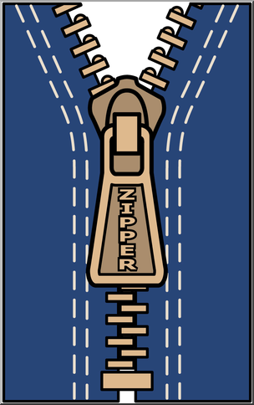**Practice at different times across the day**, not just when dressing in the morning and undressing at night.
8. **If you have a sweater or coat with extra big buttons, snaps, or zippers, allow them to practice with this.**